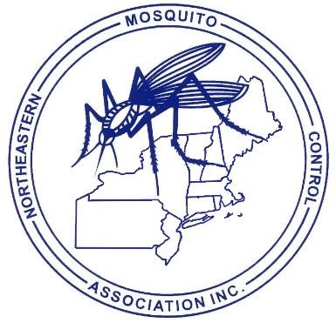**FIRST CALL FOR PAPERS – 2024**

***NORTHEASTERN MOSQUITO CONTROL ASSOCIATION***

[www.nmca.org](http://www.nmca.org/)

Hotel 1620

Plymouth MA

DECEMBER 9-11, 2024

**TITLE:**

**AUTHOR(S):**

**AFFILIATION(S):**

**MAILING ADDRESS:**

**ZIP:**

**CITY/TOWN:**

**STATE:**

**PHONE:**  ­­­______________________ **FAX:**

**E-MAIL ADDRESS:**

**PRESENTER:**

**DESCRIPTION OF PRESENTATION:** Please attach to form. The description of talk will be published in the proceeding as the abstract if no abstract or manuscript is submitted. Please e-mail abstracts and/or manuscripts to [editor@nmca.org](mailto:editor@nmca.org). The final submission date is 60 days after the meeting. Manuscripts for the proceedings are encouraged to be submitted at the Annual Meeting.

**APPROXIMATE TIME NEEDED** (15 minutes preferred):

*We will try to accommodate requests to speak on certain dates, but we will not be able to accommodate everyone if everyone requests a certain day.*

Please limit visual aids to PowerPoint® Presentations.

SUBMIT PAPER TITLES BY November 15, 2024 TO:

program@nmca.org

Ellen Bidlack, NMCA Program Committee Chair

Plymouth County Mosquito Control Project

272 South Meadow Rd.

Plymouth MA 02360

PHONE (C): (781)336-3374 PHONE (W): (781) 585-5450

Please email all abstracts and presentations under 5MB prior to the meeting to Nate Boonisar (editor@nmca.org)